"Initial Prototype Framework - Intelligent Security Log Summarization"
Ubuntu VM External IP: http://34.139.182.10:5000/
Using local desktop to connect to http://34.139.182.10:5000/
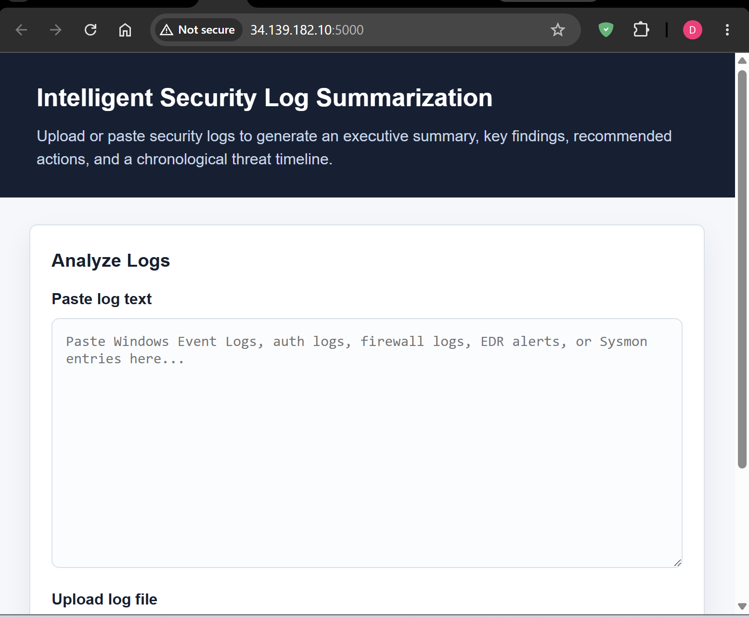

Windows VM external IP: http://34.138.232.203/
Using local desktop to connect to http://34.138.232.203/
